Upgrade Proposal

Background
Summary of current state of the field and context within which the research is located, covering current theory/state of the evidence and referring to relevant literature (500-1,000 words).
Glutamatergic transmission is thought to be dusrupted in the early stages of schizophrenia, contributing to the development of aberrant dopaminergic signalling^{1,2}, and leading to excitation-inhibition (E/I) imbalance. MR spectroscopy studies report increased glutamate in the ACC, hippocampus, and other medial temporal cortical regions of people with schizophrenia^{3–6}. Glutamate levels are associated with illness severity and treatment response³. Antipsychotic medication decreases glutamate levels^{7–9}, however non-responders have higher levels of glutamate at baseline^{10,11} and post-treatment¹¹, suggesting that modulation of glutamatergic signalling is an important for the effectiveness of pharmacological treatments. The NMDA hypofunction hypothesis of schizophrenia proposes that decreased activity of NMDA receptors at GABAergic fast-spiking PV interneurons¹² causes a disinhibition of their activity on pyramidal neurons, disrupting the excitation-inhibition (E/I) balance, and leading to increased excitation. In the early stages of the disorder, increase in glutamate drives hippocampal hyperactivty, which later contributes to hyperdopaminergia in the striatum^{1,2,13}. The role of glutamate dysfuction in symptoms is consistent with the observation thtat NMDA antagonists like phencyclidine and ketamine induces behaviours comparable to all three schizoprenia symptom dimensions (positive, negative, and cognitive symptoms)¹⁴, and repeated administration results in increased release of dopamine in rodent striatum¹³, making it an important target of translationsal research.
Alterations in synaptic function have been implicated in the disruption of E/I balance in schizophrenia¹⁵. In particular synaptic vesicle glycoprotein 2A (SV2A), a protein located on synaptic vesicles, in the presynaptic terminals, is thought to be related to glutamatergic dysfunction in schizophrenia. SV2A plays a role in neurotransmitter release, and although the exact mechanisms of actions are not known, it seems to affect excitatory and inhibitory signalling differently. The distribution of SV2A in synaptic terminals varies depending on the brain region and type of neuron (excitatory/inhibitory)^{16,17} and it seems to be preferentially associated with GABAergic rather than glutamatergic neurons¹⁸. Across different stages of maturation, the expression of SV2A with GABA and glutamate transporters differed across hippocampal regions and neuron types, and the colocalisation varied different stages of rat development¹⁶, suggesting that SV2A might have a role in maturation of the E/I balance across development. In line with this, altering SV2A expression in mice was found to affect the E/I balance¹⁹. In animal models studies, the exposure to environmental factors associated with schizophrenia risk has resulted in decrease in synaptic markers²⁰. Postmortem studies report decreased number of presynaptic²¹, but also post-synaptic²² markers in people with schizophrenia. Human SV2A PET studies reported decreased levels of SV2A in people with schizophrenia^{23,24}, which seem to appear later in the disease progression²⁵, and an altered relationship glutamate and synaptic function²⁶; in healthy participants there is a positive correlation between SV2A density and glutamate in ACC and hippocampus, but no significant correlations were found in schizophrenia²⁶, suggesting there’s a disrupted relationship between glutamate release and synaptic function. While SV2A has a role in maintaining E/I balance, conversly it is also likely that excitotoxicity caused by excess glutamate leads to synapse loss, observed as decreased SV2A in schizophrenia²⁷.
Levetiracetam (LEV) is an anticonvulsant drug that selectively binds to SV2A, and works by normalising the excitation inhibition imbalance in epilepsy. It was also found to be helpful in treating subclinical epileptiform discharges in autism spectrum disorder (ASD)²⁸. Since schizophrenia is also associated with E/I imbalance, the effects of LEV could be useful in studying schizophrenia aetiology, and could offer a translational potential. So far only one study tested the effects of LEV in schizophrenia; their findings suggesting that LEV can normalise hippocampal hyperactivity²⁹ where E/I imbalance is understood to originate. Preliminary results from a clinical trial published at clinicaltrials.gov (NCT03129360)³⁰ show decreased hippocampal CBF 2h after administering LEV to people with early psychosis, however statistical significance of the difference between group means was not reported. It is not clear whether its action is due to increase in the release of GABA or decrease in glutamate³¹. Evidence from preclinical studies on epilepsy suggests that it might restore E/I imbalance by increasing the vesicular release of GABA³². On the other hand there is also evidence for that LEV could be inhibiting glutamate release^{33–36}, this would be in line with animal studies which have shown that LEV decreases neurotransmission by decreasing the amount of available synaptic vesicles³⁷. It’s also possible that LEV affects excitatory and inhibitory neurotransmission differently when the E/I balance is disrupted compared to healthy mammals. Evidence from studies looking at the effect of LEV in epilepsy suggest that the magnitude of the effect differs when there is an imbalance between excitation and inhibition. LEV decreases EPSC in a frequency-depedent and activity-dependent manner³⁴, and it’s been proposed that it preferentially acts on hyperactive synapses^{37,38}.
There is very little studies of the effects of LEV on glutamate release in-vivo, and none in schizophrenia. To my knowledge no studies have examined the effects of LEV on glutamate and on symptoms after a single dose, which is a gap in knowledge that I aim to address with my project. Previous PET studies have consistently reported decreased SV2A density in the ACC and the hippocampus^{23,24}, therefore I will examine glutamate levelts in these two regions.

Aims and objectives
The aim of my project is to examine the relationship between synaptic connectivity and glutamatergic function in schizophrenia by commparing the change in glutamate levels after administration of LEV in healthy controls and people with schizophrenia.
I will aim to answer the following questions:
- Does modulating SV2A lead to lower glutamate levels in healthy people?
- Does modulating SV2A lead to lower glutamate levels in people with schizophrenia? Is the change different to that in healthy controls?
- Does modulating SV2A lead to change in symptoms in schizophrenia?

Hypotheses under investigation
I hypothesise that administration of LEV in healthy people will lead to decreased glutamate levels. Animal studies have shown that LEV decreases neurotransmission by decreasing the amount of available synaptic vesicles³⁷, therefore I expect that LEV will decrease the amount of glutamate released from presynaptic terminals.
Similarily I think that a decrease in glutamate will be observed in participants with schizophrenia. Evidence from studies looking at the effect of LEV in epilepsy suggest that the magnitude of the effect differs when there is an imbalance between excitation and inhibition, therefore I think that a greater decrease in glutamate will be observed in participants with schizophrenia than healthy controls.
Lastly, I believe that LEV will improve symptoms of schizophrenia. Evidence suggests that LEV could potentially normalise some changes associated with the eatiology of schizophrenia, such as normalising the E/I imbalance, hippocampal hyperactivity²⁹ and hyperperfusion³⁰. One clinical trial reported a small decrease in PANSS scores across all three symptom domains, as well as improvement in cognitive functon following 8 weeks of LEV³⁹. However, no studies examined the effect of LEV on symptoms after a single dose.

Methodology

Study design and data collection

Study design
- Single-blind, randomised, placebo-controlled trial with cross-over design.
- Participants undergo two MRI scans- one after taking placebo and the other taking levetiracetam.
- They are randomised to the order in which they receive them.
- The recruitment target is 50 participants: 25 healthy controls (HC) and 25 people with schizophrenia (SZ).
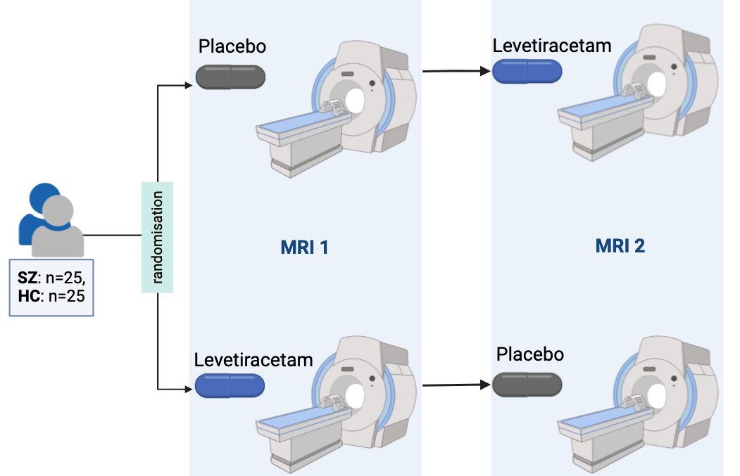
Figure 1: Study design: participants are randomised into the order in which they receive the placebo and levetiracetam (HC= healthy controls, SZ=participatns with schizophrenia)

Sample size
Based on previous MRS studies measuring glutamate changes following antipsychotic treatment, a sample size of 24 would be required to achieve 80% power within-group⁹.

Measuring glutamate
- Glutamate levels in the ACC and the Hippocampus using single voxel spectroscopy (svs) PRESS sequence. The choice of those regions was based on previous findings of decreased SV2A density ([11C]UCB-J V$​_{T}$) in the ACC in patients with schizophrenia²⁴, and altered relationship between glutamate and SV2A density in the hippocampus²⁶.
- I will also report Glx levels to verify if similar differences are observed compared to glutamate signal (This is due to limited ability to separate glutamine and glutamate using the PRESS sequence at 3T).

Behavioural measures
- Change is symptoms is assessed using Positive and Negative Syndrome Scale (PANSS).
- PANSS is administered at the screening appointment, and before and after every scan, to assess any change in symptoms related to levetiracetam.

Analysis

Change in glutamate
- MRS data processing will be done in Osprey, and values corrected for partial volume efects for concentration of Glu (and Glx) will be extracted for each participant’s scans.
- To compare the changes in levels of glutamate between participants with schizophrenia and healthy controls I will do a 2x2 ANOVA.
- I will also compare the concentration of glutamate at baseline between healthy controls and particiapnts with schizophrenia.
- I will compare the effect of levetiracetam on Glx levels in healthy controls (HC) and patients with schizophrenia (SZ). This will be visualised on a raincloud plot such as the one below.
- Below is example of data visualisation using a raincloud plot. The data used in this graph is made up.
- I will also visualise the change in glutamate after administration of LEV. Below is an example graph based on the currently available data (HC: n=3, SZ n=6)
(a) Comparison of Glu levels change between placebo and levetiracetam in HC and SZ  _{Source: Plots} | 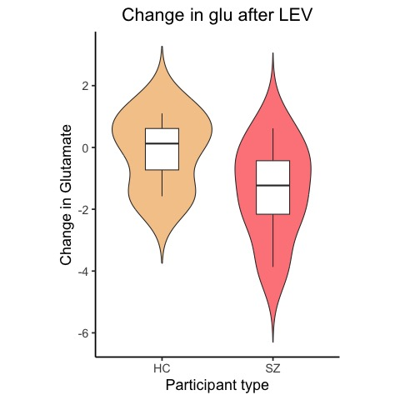  Change in glutamate
Figure 2

Change in symptoms
- PANSS score for each symptom group and overall PANSS score will be calculated for all participants.

Power calculation
Based on pprevious findings it was calculated that a sample size of 25 participants in each participant group will be sufficient to achieve the power of 0.8.

Progress made to date, including pilot work, if applicable

Progress with recruitment
So far the number of participants that completed the screening & baseline, and both MRI appointments in each group is:
- SZ: 12 (48%)
- HC: 6 (24%)
- Total: 16 (36%)
I have been working on opening new research sites at 3 NHS trusts in north London, where we will get support with recruitment from the local research delivery teams. The first research site (CNWL) is expected to open by the end of September 2024.

Progress with analyses
I am working on the setting up the data analysis pipeline for the MRS data. I have been learning Osprey and wrote the code that I continue to re-run once new data appears and troubleshoot any errors that come up.

Contribution to existing knowledge.
How the research will form a distinct contribution to existing knowledge on the subject and afford evidence of originality shown by discovery of new facts or exercise of independent critical power
This project will be the first one to examine the effects of modulating SV2A with levetiracetam on glutamate levels in schizophrenia. It was previously shown that SV2A density is decreased in schizophrenia^{23,24}, and that there is an altered relationship between Glu and SV2A in schizophrenia. The present study will provide more insight into the relationship between glutamate levels and synaptic density in schizophrenia. Such findings might have translational potential-

Personal share in investigations
Where work is done in conjunction with the supervisor and/or with collaborators or other students, a statement of the candidate’s own personal share in the investigations
I am jointly responsible for recruitment/data collection with other student. I will do my analysis and write up independently.

Planned future work and timeline for the remainder of studies.
- Data collection: October 2023 - Jan 2025
- Data analysis: May 2024 - June 2026
- Write up: November 2025 - January 2027
- Corrections to the manuscript: January 2027 - April 2027
- Thesis submission: May 2027
- Viva: July 2027
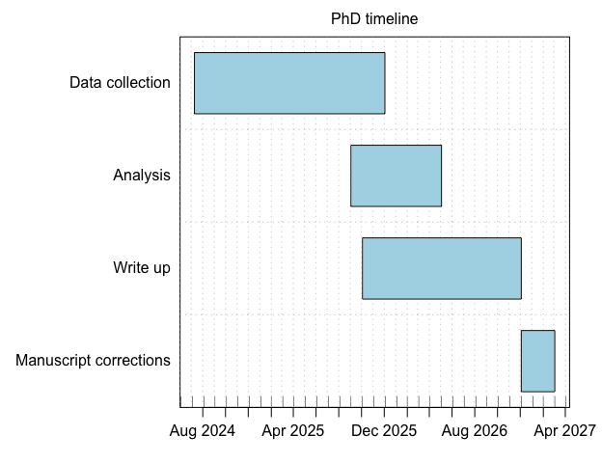
Figure 3: Gantt chart of planned work during my PhD
_{Source: Plots}

References
1. Grace, A. A. Dopamine system dysregulation by the hippocampus: Implications for the pathophysiology and treatment of schizophrenia. Neuropharmacology 62, 1342–1348 (2012).
2. Grace, A. A. Dysregulation of the dopamine system in the pathophysiology of schizophrenia and depression. Nat Rev Neurosci 17, 524–532 (2016).
3. Merritt, K. & Egerton, A. Nature of Glutamate Alterations in Schizophrenia: A Meta-Analysis of Proton Magnetic Resonance Spectroscopy Studies. Schizophrenia Bulletin 43, S84–S84 (2017).
4. Kraguljac, N. V., White, D. M., Reid, M. A. & Lahti, A. C. Increased Hippocampal Glutamate and Volumetric Deficits in Unmedicated Patients With Schizophrenia. JAMA Psychiatry 70, 1294 (2013).
5. Marsman, A. et al. Glutamate in Schizophrenia: A Focused Review and Meta-Analysis of 1H-MRS Studies. Schizophrenia Bulletin 39, 120–129 (2013).
6. Nakahara, T. et al. Glutamatergic and GABAergic metabolite levels in schizophrenia-spectrum disorders: A meta-analysis of 1H-magnetic resonance spectroscopy studies. Mol Psychiatry 27, 744–757 (2022).
7. Bojesen, K. B. et al. Treatment response after 6 and 26 weeks is related to baseline glutamate and GABA levels in antipsychotic-naïve patients with psychosis. Psychol. Med. 50, 2182–2193 (2020).
8. Jeon, P. et al. Progressive Changes in Glutamate Concentration in Early Stages of Schizophrenia: A Longitudinal 7-Tesla MRS Study. Schizophrenia Bulletin Open 2, sgaa072 (2021).
9. Egerton, A. et al. Effects of Antipsychotic Administration on Brain Glutamate in Schizophrenia: A Systematic Review of Longitudinal 1H-MRS Studies. Front. Psychiatry 8, 66 (2017).
10. Fan, L. et al. Glutamatergic basis of antipsychotic response in first-episode psychosis: A dual voxel study of the anterior cingulate cortex. Neuropsychopharmacol. 49, 845–853 (2024).
11. Reyes-Madrigal, F. et al. Striatal glutamate, subcortical structure and clinical response to first-line treatment in first-episode psychosis patients. Progress in Neuro-Psychopharmacology and Biological Psychiatry 113, 110473 (2022).
12. Nakazawa, K., Jeevakumar, V. & Nakao, K. Spatial and temporal boundaries of NMDA receptor hypofunction leading to schizophrenia. npj Schizophr 3, 7 (2017).
13. Balla, A. Continuous Phencyclidine Treatment Induces Schizophrenia-Like Hyperreactivity of Striatal Dopamine Release. Neuropsychopharmacology 25, 157–164 (2001).
14. Beck, K. et al. Association of Ketamine With Psychiatric Symptoms and Implications for Its Therapeutic Use and for Understanding Schizophrenia: A Systematic Review and Meta-analysis. JAMA Netw Open 3, e204693 (2020).
15. Howes, O. D. & Onwordi, E. C. The synaptic hypothesis of schizophrenia version III: A master mechanism. Mol Psychiatry (2023) doi:10.1038/s41380-023-02043-w.
16. Vanoye-Carlo, A. & Gómez-Lira, G. Differential expression of SV2A in hippocampal glutamatergic and GABAergic terminals during postnatal development. Brain Research 1715, 73–83 (2019).
17. Wong, T. et al. SV2A is expressed in synapse subpopulations in mouse and human brain: Implications for PET radiotracer studies. http://biorxiv.org/lookup/doi/10.1101/2024.07.15.603608 (2024) doi:10.1101/2024.07.15.603608.
18. Mendoza-Torreblanca, J. G. et al. Analysis of Differential Expression of Synaptic Vesicle Protein 2A in the Adult Rat Brain. Neuroscience 419, 108–120 (2019).
19. Venkatesan, K. et al. Altered balance between excitatory and inhibitory inputs onto CA1 pyramidal neurons from SV2A‐deficient but not SV2B‐deficient mice. J of Neuroscience Research 90, 2317–2327 (2012).
20. Silva-Gómez, A. B., Rojas, D., Juárez, I. & Flores, G. Decreased dendritic spine density on prefrontal cortical and hippocampal pyramidal neurons in postweaning social isolation rats. Brain Research 983, 128–136 (2003).
21. Osimo, E. F., Beck, K., Reis Marques, T. & Howes, O. D. Synaptic loss in schizophrenia: A meta-analysis and systematic review of synaptic protein and mRNA measures. Mol Psychiatry 24, 549–561 (2019).
22. Berdenis Van Berlekom, A. et al. Synapse Pathology in Schizophrenia: A Meta-analysis of Postsynaptic Elements in Postmortem Brain Studies. Schizophrenia Bulletin sbz060 (2019) doi:10.1093/schbul/sbz060.
23. Radhakrishnan, R. et al. In vivo evidence of lower synaptic vesicle density in schizophrenia. Mol Psychiatry 26, 7690–7698 (2021).
24. Onwordi, E. C. et al. Synaptic density marker SV2A is reduced in schizophrenia patients and unaffected by antipsychotics in rats. Nat Commun 11, 246 (2020).
25. Onwordi, E. C. et al. Synaptic Terminal Density Early in the Course of Schizophrenia: An In Vivo UCB-J Positron Emission Tomographic Imaging Study of SV2A. Biological Psychiatry 95, 639–646 (2024).
26. Onwordi, E. C. et al. The relationship between synaptic density marker SV2A, glutamate and N-acetyl aspartate levels in healthy volunteers and schizophrenia: A multimodal PET and magnetic resonance spectroscopy brain imaging study. Transl Psychiatry 11, 393 (2021).
27. Glantz, L. A., Gilmore, J. H., Lieberman, J. A. & Jarskog, L. F. Apoptotic mechanisms and the synaptic pathology of schizophrenia. Schizophrenia Research 81, 47–63 (2006).
28. Wang, M., Jiang, L. & Tang, X. Levetiracetam is associated with decrease in subclinical epileptiform discharges and improved cognitive functions in pediatric patients with autism spectrum disorder. NDT Volume 13, 2321–2326 (2017).
29. Roeske, M. J. et al. Modulation of hippocampal activity in schizophrenia with levetiracetam: A randomized, double-blind, cross-over, placebo-controlled trial. Neuropsychopharmacol. (2023) doi:10.1038/s41386-023-01730-0.
30. Goff, D. Levetiracetam in Early Psychosis. (2020).
31. Contreras-García, I. J. et al. Levetiracetam Mechanisms of Action: From Molecules to Systems. Pharmaceuticals 15, 475 (2022).
32. Luz Adriana, P. M. et al. Effect of levetiracetam on extracellular amino acid levels in the dorsal hippocampus of rats with temporal lobe epilepsy. Epilepsy Research 140, 111–119 (2018).
33. Contreras-García, I. J. et al. Synaptic Vesicle Protein 2A Expression in Glutamatergic Terminals Is Associated with the Response to Levetiracetam Treatment. Brain Sciences 11, 531 (2021).
34. Meehan, A. L., Yang, X., Yuan, L. & Rothman, S. M. Levetiracetam has an activity‐dependent effect on inhibitory transmission. Epilepsia 53, 469–476 (2012).
35. Yang, X., Weisenfeld, A. & Rothman, S. M. Prolonged Exposure to Levetiracetam Reveals a Presynaptic Effect on Neurotransmission. Epilepsia 48, 1861–1869 (2007).
36. Lee, C., Chen, C. & Liou, H. Levetiracetam inhibits glutamate transmission through presynaptic P/Q‐type calcium channels on the granule cells of the dentate gyrus. British J Pharmacology 158, 1753–1762 (2009).
37. Meehan, A. L., Yang, X., McAdams, B. D., Yuan, L. & Rothman, S. M. A new mechanism for antiepileptic drug action: Vesicular entry may mediate the effects of levetiracetam. Journal of Neurophysiology 106, 1227–1239 (2011).
38. Löscher, W., Gillard, M., Sands, Z. A., Kaminski, R. M. & Klitgaard, H. Synaptic Vesicle Glycoprotein 2A Ligands in the Treatment of Epilepsy and Beyond. CNS Drugs 30, 1055–1077 (2016).
39. Behdani, F. et al. Can levetiracetam improve clinical symptoms in schizophrenic patients? A randomized placebo-controlled clinical trial. International Clinical Psychopharmacology 37, 159–165 (2022).

